**Finding a File Cwwontaining a Particular Text String In Linux Server**

Author: Vivek Gite Last updated: September 19, 2022 [65 comments](https://www.cyberciti.biz/faq/howto-search-find-file-for-text-string/#comments)



I have been using Linux for a while on my server and have a large collection of the text file everywhere. I’m interested in learning about searching a text string. Can you tell me how I find a file containing a particular text string on my Linux server? What Linux command can find text in files?  
  
I have to admit that there are tens and thousands of text files on any Linux or Unix based server. Finding and locating those files can be done with the find command. Unfortunately, find command cannot look inside a text file for a string. You need to use the [grep command](https://www.cyberciti.biz/faq/howto-use-grep-command-in-linux-unix/?utm_source=Linux_Unix_Command&utm_medium=faq&utm_campaign=nixcmd). The [grep command](https://www.cyberciti.biz/faq/howto-use-grep-command-in-linux-unix/?utm_source=Linux_Unix_Command&utm_medium=faq&utm_campaign=nixcmd) or [egrep command](https://www.cyberciti.biz/faq/grep-regular-expressions/?utm_source=Linux_Unix_Command&utm_medium=faq&utm_campaign=nixcmd" \o "Regular expressions in grep ( regex ) with examples) searches the given input FILEs for lines containing a match or a text string.

| **Tutorial details** | |
| --- | --- |
| Difficulty level | [Easy](https://www.cyberciti.biz/faq/tag/easy/) |
| Root privileges | No |
| Requirements | Linux terminal |
| Category | [Searching](https://www.cyberciti.biz/faq/howto-search-find-file-for-text-string/#Searching) |
| Prerequisites | find and grep commands |
| OS compatibility | BSD • [Linux](https://www.cyberciti.biz/faq/category/linux/) • [macOS](https://www.cyberciti.biz/faq/category/mac-os-x/) • [Unix](https://www.cyberciti.biz/faq/category/unix/) • WSL |
| Est. reading time | 5 minutes |

Advertisement

**grep command syntax for finding a file containing a particular text string**

The Linux syntax to find string in files is as follows:

grep "text string to search" directory-path  
grep [option] "text string to search" directory-path  
grep -r "text string to search" /directory-path  
grep -r -H "text string to search" directory-path  
grep -E -R "word-1|word-2" /path/to/directory  
# Find string in files on Linux #  
grep -E -w -R "word-1|word-2" directory-path

Let us see some common example on how to use grep to search for strings in files.

**How to search and find all files for a given text string**

In this example, search for a string called ‘redeem reward’ in all text (*.txt) files located in /home/tom/ directory, use:

$ grep "redeem reward" /home/tom/*.txt

Let us find text called “redeem reward” in files under Linux:

$ grep "redeem reward" ~/*.txt

**Task: Search all subdirectories recursively to find text in files**

You can search for a text string all files under each directory, recursively with -r option:

$ grep -r "redeem reward" /home/tom/

OR

$ grep -R "redeem reward" /home/tom/

Look for all files containing cacheRoot text on Linux:

$ grep -R cacheRoot /home/vivek/

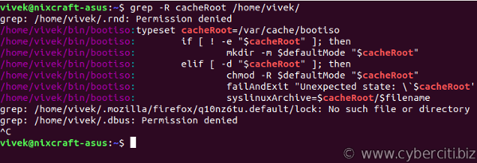

Trying to find all files containing specific text on my Linux desktop

I want to search the whole Linux server for a string. In other words, use the following command to search for a word called “barfoo”:

$ sudo grep -R "barfoo" /

The / indicate root file system. The above command may take a lot of time. Hence, it is better to restrict the search to particular directory as per your needs:

$ sudo grep -R "barfoo" /etc/

**Task: Only display filenames**

By default, the grep command prints the matching lines. You can pass -H option to print the filename for each match:

$ grep -H -r "redeem reward" /home/tom

Sample outputs:

filename.txt: redeem reward

foobar.txt: redeem reward

...

To just display the filename use the cut command as follows:

$ grep -H -R vivek /etc/* | cut -d: -f1

Sample outputs:

filename.txt

foobar.txt

...

**Task: Suppress file names**

The grep command shows output on a separate line, and it is preceded by the name of the file in which it was found in the case of multiple files. You can pass the -h option to suppress inclusion of the file names in the output:

$ grep -h -R 'main()' ~/projects/*.c

**Task: Display only words**

You can select only those lines containing matches that form whole words using the -w option. In this example, search for word ‘getMyData()’ only in ~/projects/ dirctory:

$ grep -w -R 'getMyData()' ~/projects/

**Task: Search for two or more words**

Use the egrep command as follows:

$ grep -E -w -R 'word1|word2' ~/projects/

**Task: Hide warning spam**

grep command generate error message as follows due to permission and other issues:

No such file or directory  
No such device or address  
Permission denied

To hide all errors or warning message spam generated by the grep command, append [2>/dev/null to grep command](https://bash.cyberciti.biz/guide/dev/null_discards_unwanted_output). This will send and hide unwanted output to /dev/null device:

$ grep -w -R 'getMyData()' ~/projects/ 2>/dev/null

**Task: Display matched text in color**

Pass the --color option to the grep command display matched text/words in color on the terminal:

grep --color 'word' file

grep --color -R 'word' /path/to/dir

grep --color -R "192.168.1.5" /etc/

grep --color -R -h "192.168.1.5" /etc/

grep --color -R -h "192.168.1.5" /etc/ 2>/dev/null

Sample outputs:

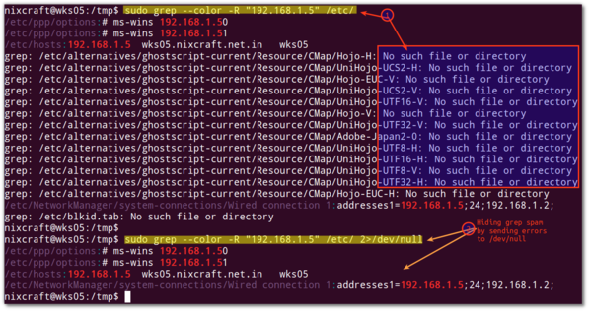

Fig.01: grep command in action with colors and hiding the warnings on screen

**Task: Ignore case**

Our final example ignore case distinctions in both the search PATTERN and the input files:

$ grep -i -R 'word' /path/to/dir  
$ grep -i -r 'income tax' ~/accounting/

**How do I find all files containing specific text on Linux?**

The syntax is:

$ grep -E 'pattern' -rnw /path/to/dir/  
$ grep -E 'word1|word2' -rnw /home/vivek/backups/

**Summing up**

You learned how to search and find a file containing a particular text string (words) under Linux using the grep command.

**Finding text strings within files using grep**

In this example search for lines starting with any lowercase or uppercase letter:

$ grep "^[a-zA-Z]" -rns ~/projects/texts/

Where,

* -r – Recursive search
* -R – Read all files under each directory, recursively. Follow all symbolic links, unlike -r grep option
* -n – Display line number of each matched line
* -s – Suppress error messages about nonexistent or unreadable files
* -w – Only work on words i.e. search only those lines containing matches that form whole words
* -l – Show the name of each input file when match found
* -i – Ignore case while searching